

**Licenciatura en Sistemas de Información**

**Trabajo Práctico N°3c**

**Materia**: Ingeniería de Software II

**Alumnos**: Putallaz Gian

**Profesor**: Dr. Pedro E. Colla

**Ayudante**: Hernán Sanchez

1)

[*https://github.com/gianquito/UADER_IS2_Putallaz_TP_1/commit/a87528c7f5db6f1e821ab889bc672a5291f4f462*](https://github.com/gianquito/UADER_IS2_Putallaz_TP_1/commit/a87528c7f5db6f1e821ab889bc672a5291f4f462)

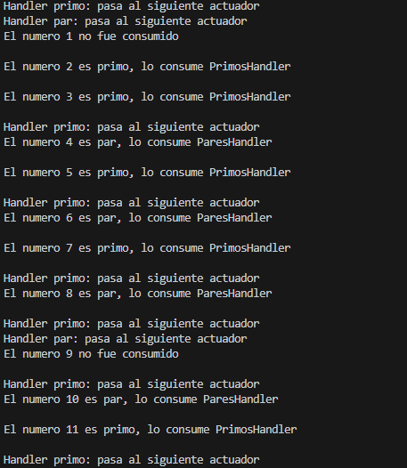

2)

[*https://github.com/gianquito/UADER_IS2_Putallaz_TP_1/commit/99f75a74d179a230812ddfb69800663f1bc18c02*](https://github.com/gianquito/UADER_IS2_Putallaz_TP_1/commit/99f75a74d179a230812ddfb69800663f1bc18c02)

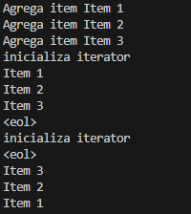

3) [*https://github.com/gianquito/UADER_IS2_Putallaz_TP_1/commit/bc00eef148db508f92f74dfa8aed248258f81a38*](https://github.com/gianquito/UADER_IS2_Putallaz_TP_1/commit/bc00eef148db508f92f74dfa8aed248258f81a38)

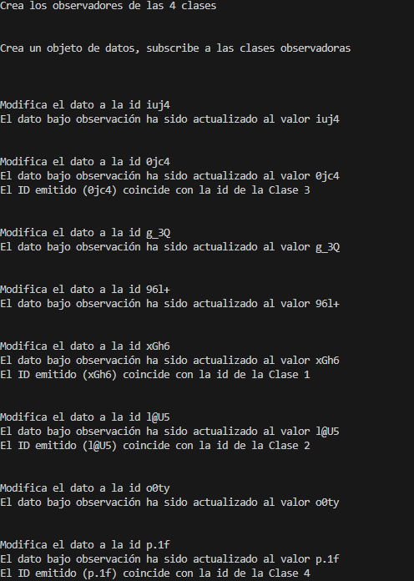

4)[*https://github.com/gianquito/UADER_IS2_Putallaz_TP_1/commit/9b90f196201b9566034381d8800c00dabf462207*](https://github.com/gianquito/UADER_IS2_Putallaz_TP_1/commit/9b90f196201b9566034381d8800c00dabf462207)

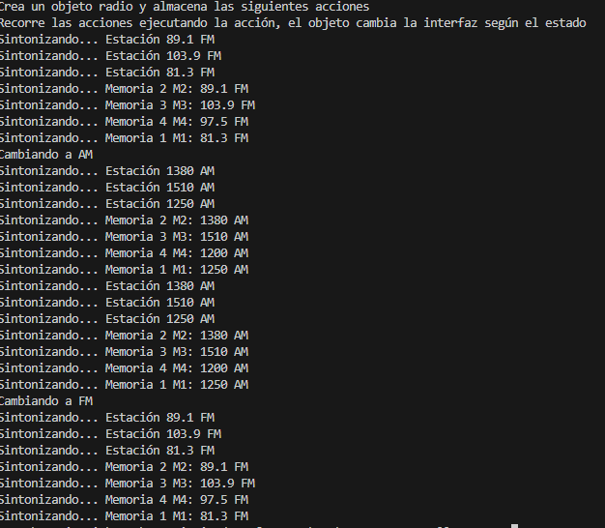

5)[*https://github.com/gianquito/UADER_IS2_Putallaz_TP_1/commit/e1339c64b98962695603ca1703294b2a285e081d*](https://github.com/gianquito/UADER_IS2_Putallaz_TP_1/commit/e1339c64b98962695603ca1703294b2a285e081d)

